Transmitter Setup Manual Convention

1. A black and silver remote control

   Description automatically generatedFutaba T14SG

Figure 1. Futaba T14SG Transmitter

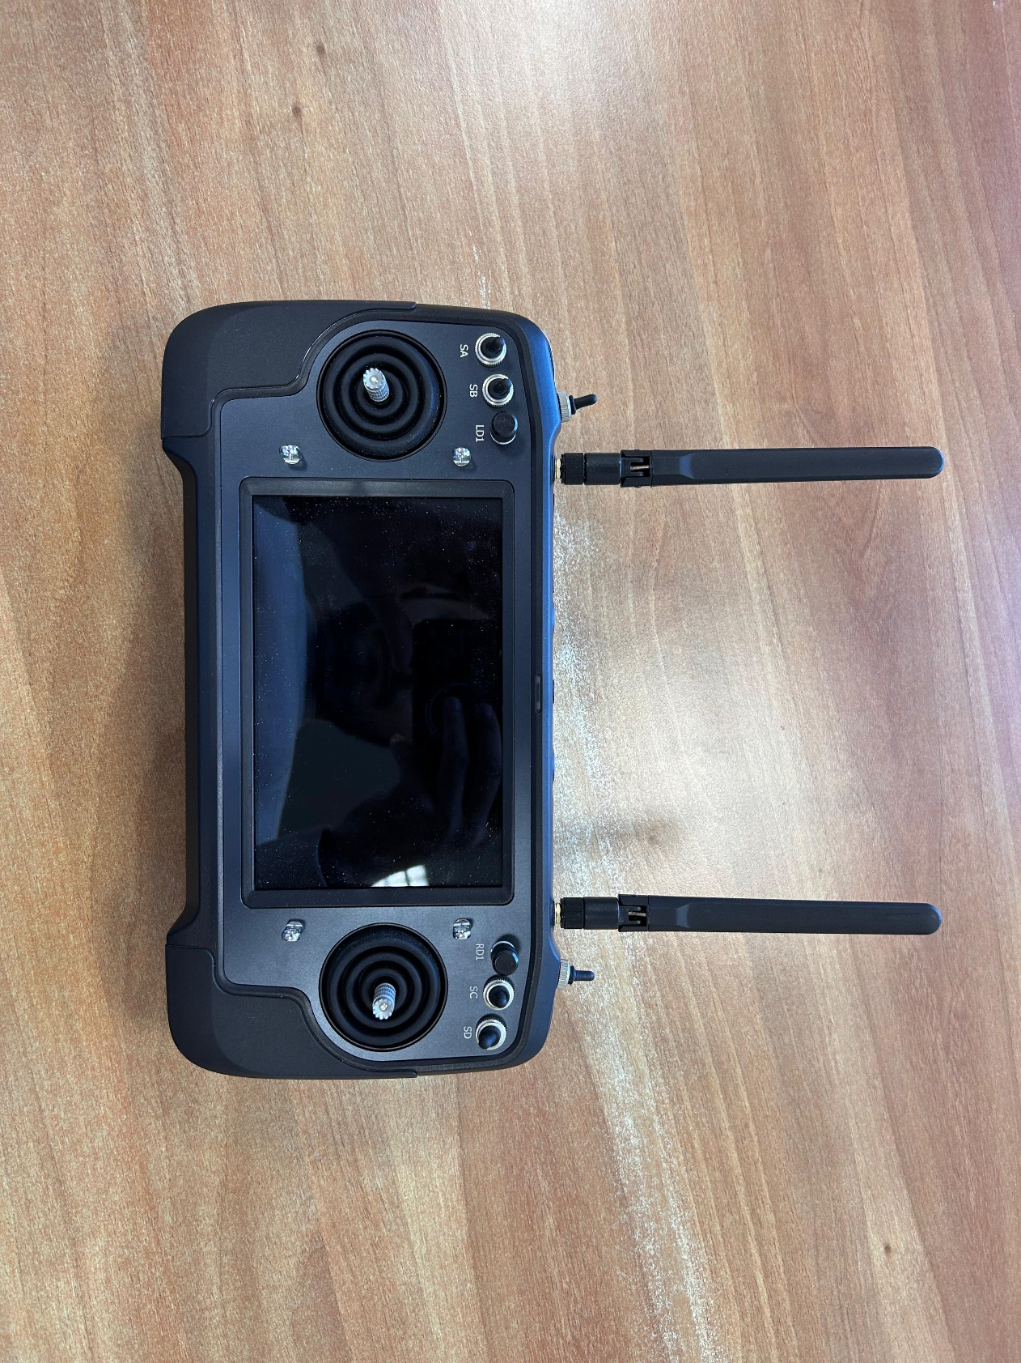

Figure 2. SiYi M32

Table 2. Standard Futaba Transmitter Settings

|  |  |  |  |  |  |  |  |
| --- | --- | --- | --- | --- | --- | --- | --- |
| RC Channel Assignment - Futaba | | | | | | | |
| **RC Channel** | PX4 Assignment | Used in LEAF FC? | Futaba Assignment | Min Value | Max Value | Min Val Pos | Max Val Pos |
| CH1 | RC Roll | YES | J1 | -100 | +100 | West | East |
| CH2 | RC Pitch | YES | J2 | -100 | +100 | South | North |
| CH3 | RC Throttle | YES | J3 | -100 | +100 | South | North |
| CH4 | RC Yaw | YES | J4 | -100 | +100 | East | West |
| CH5 | - | - | - | - | - | - | - |
| CH6 | - | - | - | - | - | - | - |
| CH7 | Kill-Switch | NO | SF | -100 | +100 | Down | Up |
| CH8 | - | - | - | - | - | - | - |
| CH9 | - | - | - | - | - | - | - |
| CH10 | - | - | - | - | - | - | - |
| CH11 | - | - | - | - | - | - | - |
| CH12 | - | - | - | - | - | - | - |

*Note that top of RC points north.

Table 3. Standard SiYi Transmitter Settings

|  |  |  |  |  |  |  |  |
| --- | --- | --- | --- | --- | --- | --- | --- |
| RC Channel Assignment – SiYi M32 | | | | | | | |
| **RC Channel** | PX4 Assignment | Used in LEAF FC? | SiYi Assignment | Min Value | Max Value | Min Val Pos | Max Val Pos |
| CH1 | RC Roll | YES | J1 | +1050 | +1950 | West | East |
| CH2 | RC Pitch | YES | J2 | +1050 | +1950 | South | North |
| CH3 | RC Throttle | YES | J3 | +1050 | +1950 | South | North |
| CH4 | RC Yaw | YES | J4 | +1050 | +1950 | East | West |
| CH5 | - | - | - | - | - | - | - |
| CH6 | - | - | - | - | - | - | - |
| CH7 | Kill-Switch | NO | SE | +1050 | +1950 | Down | Up |
| CH8 | - | - | - | - | - | - | - |
| CH9 | - | - | - | - | - | - | - |
| CH10 | - | - | - | - | - | - | - |
| CH11 | - | - | - | - | - | - | - |
| CH12 | - | - | - | - | - | - | - |
| CH13 | - | - | - | - | - | - | - |
| CH14 | - | - | - | - | - | - | - |
| CH15 | - | - | - | - | - | - | - |
| CH16 | - | - | - | - | - | - | - |